TD220MAX releases after 1.2.5 include upgraded Precision Time Protocol (PTP) support. The PTP Configuration menu has changed and no longer requires setup of PTP Event Port, PTP General Port, and PTP Domain Address. The radio now uses a slave-only, IPv4 PTP configuration. When no profile is selected, the radio uses multicast PTP messaging to automatically select a grandmaster. The user may select the domain number and delay mechanism via the PTP Configuration menu.
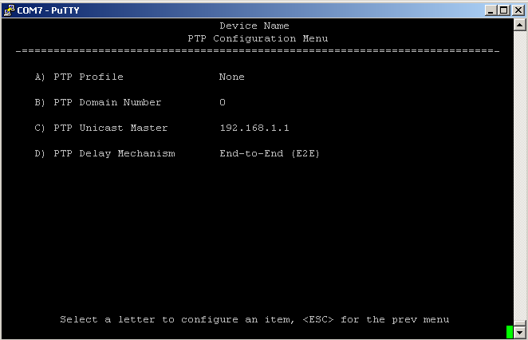
When the ITU-T G.8265.1 Telecom Profile is selected, the radio uses unicast PTP messaging and negotiation. The user may select the domain number and must set an address for the master.
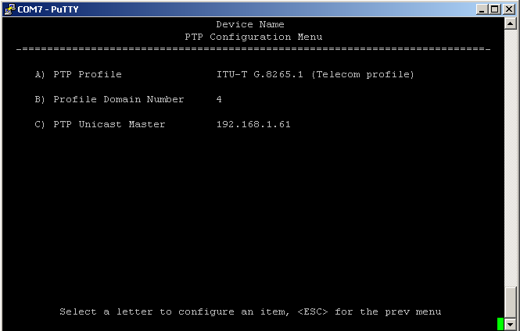
Releases after 1.2.5 also introduce timing source fallback support. The System Configuration menu Timing Source setting now includes options "GPS w/ PTP fallback" and "PTP w/ GPS fallback".
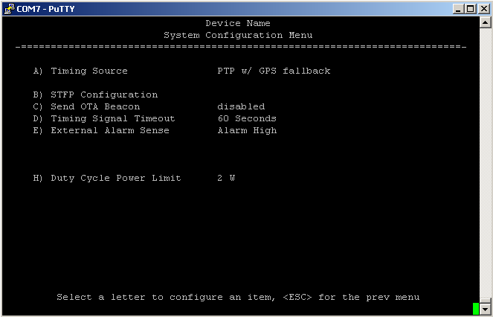
When the radio reboots using one of these options, the active timing source is set to the first source named in the option. If that source doesn’t become valid and the fallback source is valid, the active timing source changes to the fallback. These options don't provide a preferred source though. If the original timing source becomes valid, the radio will not switch back unless the current source fails.
The status of each timing source is presented in the Statistics, Clock Source Status menu. The Switch Clock Source item is available when the Timing Source is one of the fallback options, allowing user-initiated source switching.
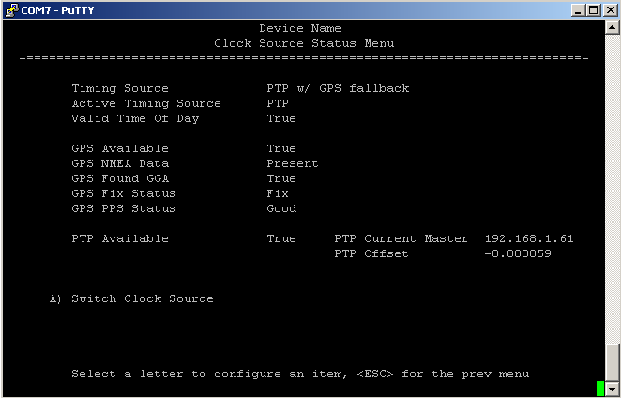
An example multicast grandmaster configuration for the Spectracom SecureSync is shown below. Use this when the radio PTP Profile setting is None.
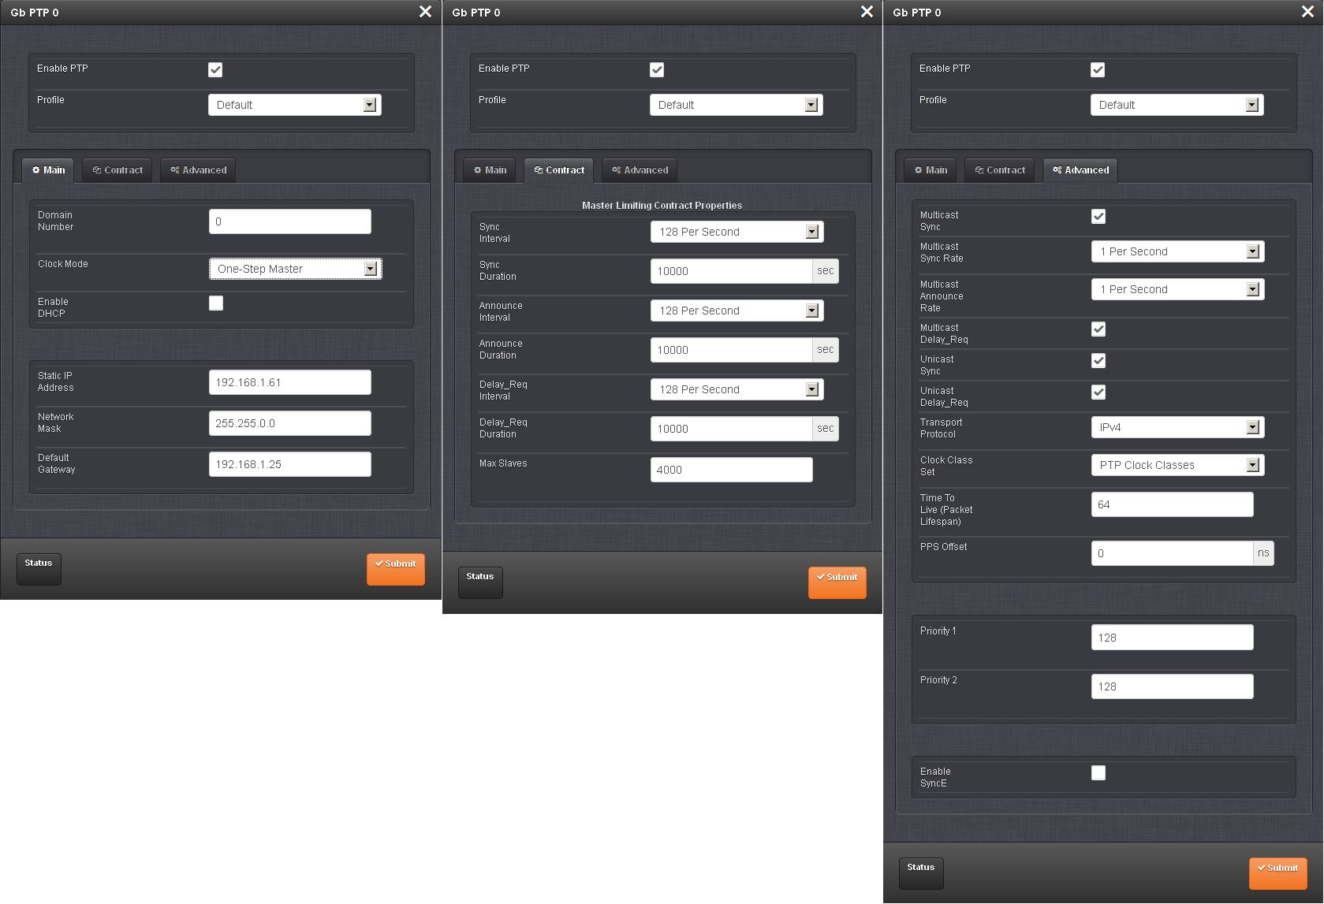
An example unicast grandmaster configuration for the Spectracom SecureSync is shown below. Use this when the radio PTP Profile setting is ITU-T G.8265.1 Telecom profile.
