GE MDS NETview MS
Quick-Start Guide
input.doc
GE MDS 05-4635A01
Revision A: April 4, 2007

Version 0.4
7/31/2026

GE MDS, LLC

Contents
1 Introduction 1
1.1 Purpose 1
1.2 Intended Audience 1
2 System Description 2
2.1 Overview of NETview system 2
3 Installation 4
3.1 Installation Contents 4
3.1.1 Java Runtime Engine 4
3.1.2 TFTP Server 4
3.1.3 Database 4
3.1.4 NETview application 5
3.2 Installation from executable file 5
3.2.1 Setup.exe 5
Java Runtime Engine 5
TFTP Server 5
3.3 Installation from CD 5
4 Getting Started 7
4.1 Logging In 7
4.2 Home screen 8
4.3 Maps 9
4.3.1 Creating a new Map 10
3.3.1.1 Creating and Adding nodes to a map 11
3.3.1.1.1 SNMP Devices 13
3.3.1.1.2 Serial/Transparent Devices 14
3.3.1.1.3 EntraNET Remote Devices 16

Introduction

Purpose
The purpose of this document is for users of GE MDS NETview MS (NETview) to become acclimated to the new interface introduced in version 5.0. This document will provide an overview of the options the user has from the NETview home screen, and will explain how to create a map and how to create and add radio nodes to that map.

Intended Audience
This document is intended for users who are already familiar with network management. This document assumes that the reader understands common network management terms, as well as the network topology.

System Description

Overview of NETview system
Figure 1: NETview 5.0 overview

Core Applications Operations – The Core Application communicates with the radio devices out in the field, collecting performance statistics, trap information, and diagnostic information from the devices. The engine uses nodes to represent the device in the system and to act as a medium between the NETview system and the radio device.
Network View – The NETview Network view are a collection of visual panels that provide a variety of ways to view the same network management information. Maps and charts are common ways to view network management operations. Each visual display is a user customizable way to view the network management operation and results.
Database – The NETview Database stores the performance statistics and trap information for NETview managed devices. This information can later be viewed in the display.
Applications Files – NETview stores all application specific information, such as maps and users information in formatted files. The information in these files is specifically for the operation of the application.
Node Agents – When the NETview application is running, each node under management is represented by a small part static part of the application referred to as a Node agent. As long as the core applications is managing a particular node, the agent is present.

Installation

Installation Contents
The NETview application requires three major support components in order to perform the responsibilities of network management. This section offers an explanation and purpose of each.

Java Runtime Engine
The Java Runtime Engine provides an operational interface between the Operating system and a Java application. All applications written in Java require this middleware in order to run.
During the installation of NETview, the installer checks the system for the presence of the JRE version 1.5. If it is not found, or an earlier version, the install script installs version 1.5 or updates the current engine.

TFTP Server
NETview contracts the services of file transfer to a small external application that is optimized to perform such operations. This application is a Trivial File Transfer Protocol server that is used to upgrade remote radio firmware and collect remote files such as event logs.
During installation of NETview, the install script checks the system for this application. If it is not found, the TFTP server installation is executed. Once the TFTP installation is complete, the operation returns to complete the NETview installation.

Database
Any software application that requires power-off storage of data employs the services of a database. NETview is no exception and uses this capacity to store information collected from nodes through polling, along with traps received by the management work station.
The NETview installation script installs a Microsoft Access database. NETview uses this database directly and does not require the Access application to be installed. Since NETview uses standard SQL queries, other databases can be used in place of Access.
After NETview is installed, an existing NETview database can be imported through a startup window or the NETview ‘Tools’ menu.

NETview application
The last module that is installed in the NETview application itself. If the default navigation path was used during installation, the NETview executable, along with all the support files, can be found:
C:/Program Files/Microwave Data Systems/MDS NETview 5.0

Installation from executable file
This section describes the installation of NETview from an executable file. If the application was downloaded from the GE MDS web site, the executable file, along with support files, will need to be extracted from the compressed format. Once the files are available, the application can be installed.

Setup.exe
Among the unpacked files, find and open the file labeled setup.exe. This will start the process of checking the system for the installed resources and placing folders and files in correct locations. During the installation the user is queried for a few answers regarding particulars of the installation and the target system.

Java Runtime Engine
The installer starts by checking for, and the version of, the Java Runtime Engine. If the installation, or an update, is necessary, the installer diverts the operation to the Java installer. Once the Engine installation is complete, operation is returned to the NETview installer.

TFTP Server
After checking the installation of the Java Runtime Engine, the NETview installer then checks the system for a previous installation of the TFTP server. If the installation is necessary, the installer diverts the operation to the TFTP Server installer. The TFTP Server installer will query the user for a few answers regarding particulars of the system, such as the directory where the TFTP Server will be installed. Once the TFTP Server installation is complete, operation is returned to the NETview installer.

Installation from CD
This section describes the installation of NETview from a packaged CD-ROM. The NETview installation from a CD is similar to the installation from an executable file as the same setup.exe file is executed and the same operations are performed. The only difference between installation from a CD and installation from an executable file is that the installation from a CD is self-executing. Once the user inserts the NETview CD-ROM into their computer’s CD-ROM drive, the CD will automatically start the installation process.

Getting Started

Logging In
Once the NETview program has been loaded, the user will be prompted to log into the system:
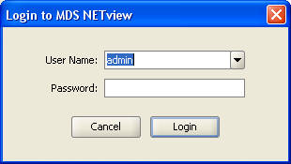
Figure 1.1 – Login to GE MDS NETview screen
For first-time users of the system, the default username and password is “admin”. Adding and editing users can be done within the Users option on the NETview Home Screen (to be described later). It is highly recommended that first time users change their default password for security reasons.

Home screen
Once the user has logged into NETview, the system displays the NETview home screen:
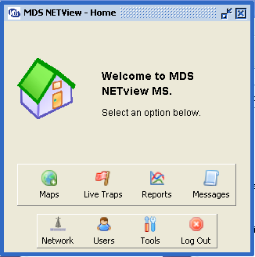
Figure 1.2 – The NETview Home Screen
From here the User can choose what to do from the options:
Maps – View and create maps of the network. The user can also add nodes to the System through the maps. (Basic Map operations will be discussed later in this document).
Live Traps – Track traps in real-time. This displays the traps NETview has received since startup in a table for users who want to simply view traps as they come in.
Reports – View NETview reports. This allows the user to view Performance Statistics and Trap information in report and chart form.
Messages – View System Messages in real-time. This display shows the user the messages the system has sent to the display, such as incoming traps and radio polling status.
Network – View all radios on the NETview network. This display lists all the nodes in the system, regardless of which map the node is on, or whether the node is even on a map.
Users – View and edit user properties. The user can add users and edit user properties, such as passwords.
Tools – Modify system settings. The user can edit system settings such as polling intervals and database settings.
Log Out – Logout of the application. When a user logs out of the application, the system will continue to run, collecting information from the radio devices until the application is closed.

Maps
Maps are the default way in which users can view and manage their networks through NETview. A map is a visual representation of a network or part of a network containing nodes that the NETview system is aware of.
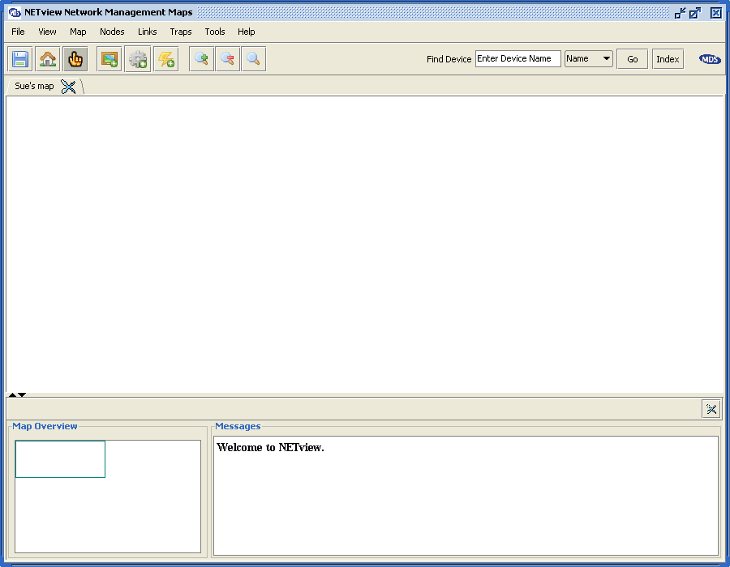
Figure 1.3 – The NETview Map Display
A Map Display (Figure 1.3) contains a panel displaying the map itself with a Tabbed heading containing the map name. Above the map are toolbars with network management and display options. Below the map are a Map Overview (a more “global” look at the map) and a messages panel, containing messages being sent by the system.
On a Map Display a user can open and view multiple maps at one time, allowing the user the ability to view their network as multiple “sub-networks” for easier management. Multiple maps can be traversed using the tabbed headers for each Map. Multiple Map Displays can also be opened and viewed for users that wish to view each map in a separate window, or sets of maps in separate windows.
Users can create and open maps by selecting the Maps button on the NETview home screen.

Creating a new Map
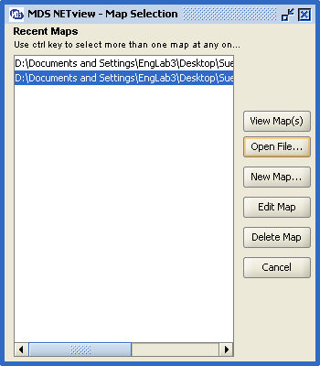
Figure 1.4 – NETview Map Selection Screen
Upon clicking the Maps button on the NETview home screen, the system will display the Map Selection screen. (See figure 1.4) To create a new Map select the “New Map” button to bring up a Map Properties dialog for the new map:
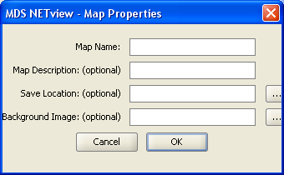
Figure 1.5 Map Properties Dialog
The Map Properties are as follows:
Map name – The name to give the map. This will be displayed within the Map Display, and be used to differentiate between maps. This will also be the default file name for the map.
Map Description – An optional description of what the map is of. The map will still be functional even if this option is left blank.
Save Location – An optional location to store the map File. If left blank, the Map file will be stored in the “maps” folder found in the location that NETview was installed to.
Background Image – An optional graphic that will be laid underneath the nodes on the map. The image may be a geographical map of the area where the radio network is setup. If left blank, the background will default to a blank white background. This option can also be changed while displaying the map.
Once the map has been created (by clicking the OK button), the map will be added to the list of “Recent Maps” on the Map selection screen. To open the map, select it from the “Recent Maps” list and click the “View Map(s)” button.
Once the map is opened, the user can start to add nodes.

3.3.1.1 Creating and Adding nodes to a map

NETview can manage three types of radio devices:
- SNMP Devices – any device that has an IP Address, can speak the SNMP protocol and can be accessed through an Ethernet port
- Serial/Transparent Devices – A SCADA device that speaks the DLink protocol and is accessed through either a COM port or terminal server.
- EntraNET Remote Devices – An GE MDS EntraNET-900 Remote device that can only be accessed through an associated EntraNET Access Point.
To create a new node within the system and add it to the map, click the “New Node” button in the Map Display (see Figure 1.6).
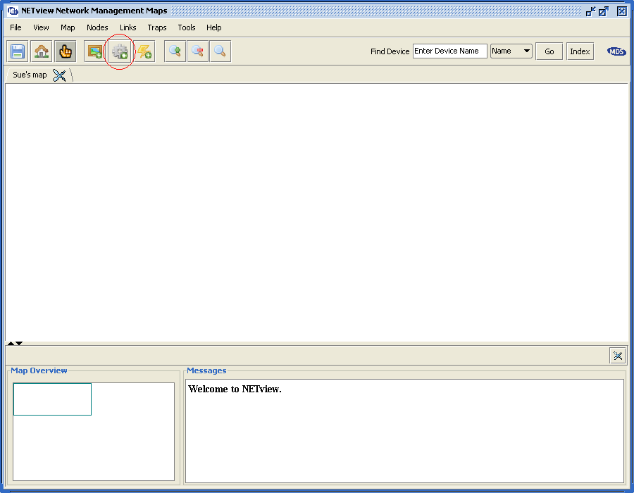
Figure 1.6 – The Map Display, with the Create New Node button circled in red.
A Node Properties Configuration Dialog will open with the tabs for adding a node of one of the three types of radio devices (described later). Once the node is created, it is sent to the system to discover what device the node is supposed to represent. If the device is a non-GE MDS device, or cannot be communicated with, the node will be created as a generic device.
Once a device is in the NETview system, it can be added to any number of maps. Similarly, if the device is in the NETview system, it will be managed even if it is removed from all maps (as long as the device was not removed from the system).

3.3.1.1.1 SNMP Devices

In a Node Properties Configuration dialog, the default option is to create an SNMP Device node.
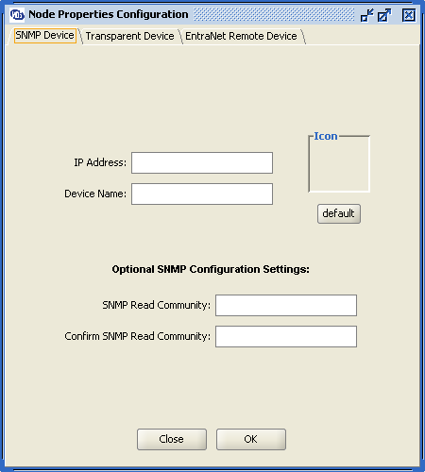
Figure 1.7 – The Node Properties Configuration dialog with SNMP Device tab selected
The SNMP Device node options are:
IP Address – The IP address of the device. This is the identifier the NETview system will use to communicate to the device, and must be unique in the network.
Device Name – An optional name for the device. The device name will display on the map underneath the node. If left blank, the device name will default to the IP Address
Read Community – The SNMP community string to authorize NETview to read information from the device. In GE MDS devices, the default Read Community is “public”.
Write Community – The SNMP community string to authorize NETview to send information to the device. In GE MDS devices, the default Write Community is “private”.

3.3.1.1.2 Serial/Transparent Devices

In a Node Properties Configuration dialog, another option is to create a “Transparent” or serial device.
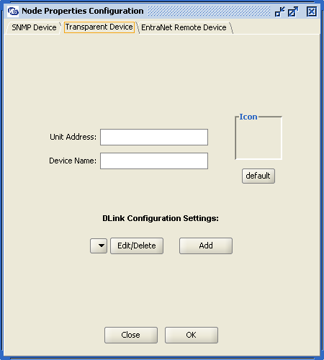
Figure 1.8 - The Node Properties Configuration dialog with Transparent Device tab selected
The Transparent Device node options are:
Unit Address – The unit address of the device. This is the ID of the device, and in most GE MDS transparent devices is the last four digits of the serial number.
Device Name – An optional name for the device. The device name will display on the map underneath the node. If left blank, the device name will default to the unit address.
DLink Configuration Settings – In order to communicate with transparent devices, the DLink communication connection needs to be set. For each transparent radio, the user must select what connection to use. To create a new connection, click the “Add” button in the Transparent Node Properties Configuration Option. There are two types of connections for transparent devices: Direct connection through a COM port, and connection via a terminal server.

3.3.1.1.2.1 Direct Connection

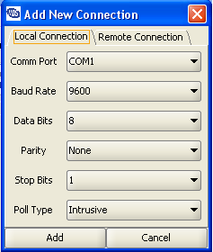
Figure 1.9 – Add a new Local Connection dialog
The Add New Connection dialog defaults to a Local Connection, or Direct Connection through a COM port on the Computer running NETview. The options for a local connection are:
Comm Port – Which comm port the device will be connected through
Baud Rate – The Baud rate the device and comm port communicate at. This must be the same as the baud rate set in the device.
Data Bits – The Data Bits value of the Device being connected to. All devices connecting to this comm port must have the same Data Bits value (default is 8)
Parity – The Parity value for communications of the device. All devices connecting to this comm port must have the same Parity value (default is none (n)).
Stop Bits – The Stop Bits value for communications of the device. All devices connecting to this comm port must have the same Stop Bits value (default is 1).
Poll Type – Transparent devices can either be polled intrusively or non-intrusively. Intrusive polling is instant, however requires taking down the network, and a likely loss of payload data. Non-intrusive polling does not take down the network, but receives a little bit of information with every sent packet. Non-intrusive polling is slower, however recommended to keep the network running.
Baud Rate, Data Bits, Parity, and Stop Bits are all values that are set within the transparent device. Please check device documentation for how to retrieve these values. NETview will not communicate with transparent devices if these values are not properly set.

3.3.1.1.2.2 Connection via a Terminal Server

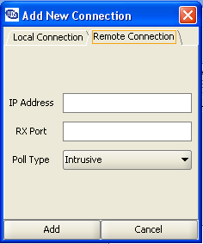
Figure 1.10 – Add a new Remote Connection dialog
The Add New Connection Dialog also has a tab for remote connections. A Remote Connection is used to communicate to a transparent device through a terminal server. It is expected that the terminal server be properly configured prior to being used in NETview. The options for a remote connection are:
IP Address – The IP Address of the terminal server.
RX Port – The configured port on the terminal server that the transparent devices are connected to.
Poll Type – Transparent devices can either be polled intrusively or non-intrusively. Intrusive polling is instant, however requires taking down the network, and a likely loss of payload data. Non-intrusive polling does not take down the network, but receives a little bit of information with every sent packet. Non-intrusive polling is slower, however recommended to keep the network running.

3.3.1.1.3 EntraNET Remote Devices

In a Node Properties Configuration dialog, the last option is to create an EntraNET Remote device node. In order to communicate with an EntraNet Remote device, NETview requires that the associated EntraNET Access Point be already in the system. NETview will know how to match remote nodes with their associated access point nodes for communications purposes.
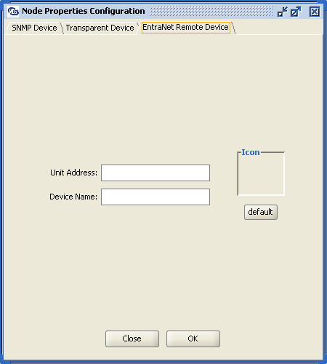
Figure 1.11 - The Node Properties Configuration dialog with EntraNet Remote Device tab selected
The entraNET Remote device node options are:
Unit Address – The unit address of the device. This is the identifier the NETview system will use to communicate to the device, and is known to the Access Point.
Device Name – An optional name for the device. The device name will display on the map underneath the node. If left blank, the device name will default to the unit address.

