Microwave Data Systems Inc.
MDS NETview MS TM



Installation Guide for Version 4.1

January, 2006

TABLE OF CONTENTS

GETTING STARTED ………………………………………………….. 3

INSTALLING MDSnv SERVER 4.1 ………………………………….. 4

UPDATING A PREVIOUS INSTALLATION OF MDSnv SERVER
TO 4.1 …………………………………………………………… 6

UNINSTALLING MDSnv SERVER 4.1 ……………………………… 6

INSTALLING MDS NETview CLIENT 4.1 ………………………….. 7

UPDATING A PREVIOUS INSTALLATION OF MDS NETview CLIENT
TO 4.1 …………………………………………………………… 8

UNINSTALLING MDS NETview CLIENT 4.1 …………………….… 8

INSTALLING MDS TFTP SERVER ………………………………….. 8

INSTALLING TRAPTRACKER MANAGER ………………………… 9

TROUBLESHOOTING ………………………………………………… 10

GETTING STARTED

First, start Windows and close any applications that may be running. Insert the NETview CD into the computer’s CD-ROM drive. After a moment the NETview Launch program will begin. If it does not, choose Run from the computer’s Start menu, type the letter of the CD drive, followed by a colon, backslash (\), and the word “launch” e.g. d:\launch.

If installing from a .zip file, extract the files to the destination folder (keep note of where that folder is). Go into that folder, open the “4.1.0” folder and run the Launch application. After completing installation, the install folder may be deleted.


Figure 1: the Loaded Launch program, “Install Software” highlighted.

Once the Launch program has been loaded (Figure 1), select “Install Software” from the list to bring up Installation options. Other options include “Contact Us” for Microwave Data Systems contact information, “Browse CD” to look at the contents of the Installation disk, and “Exit” to exit the launch program.

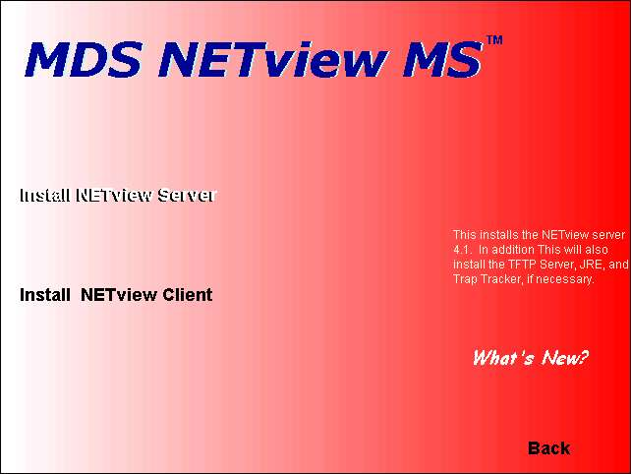
Figure 2: Inside the “Install Software” option. “Install NETview Server” highlighted.

Once in “Install Software”, choose which program to Install, the MDS NETview Server (MDSnv Server), or MDS NETview Client (MDS NETview) (Figure 2). Depending on what is on the system, the Installers will install NETview 4.1, or uninstall any version of NETview. Choosing “What’s New?” will bring up a screen displaying what is changed in the latest versions of MDS NETview MS, MDS TFTP Server, TrapTracker, and the Java Runtime Environment. “Back” will take you back to the main menu of the launcher.

INSTALLING MDSnv SERVER 4.1

The NETview Server installer will also check that the system has an up to date version of the Java Runtime Environment (JRE). If not found, the installer will install JRE version 1.5. After installing the JRE, the user will be prompted to reboot. If the user chooses to reboot, they may have to restart the MDSNETview MS installation.

Setup will install the server to the folder location found in Destination Folder. It is recommended that the default destination be used, however, selecting the browse button to choose another folder can change this. Click Next.

The installer will copy the necessary files from disk to run the NETview server.

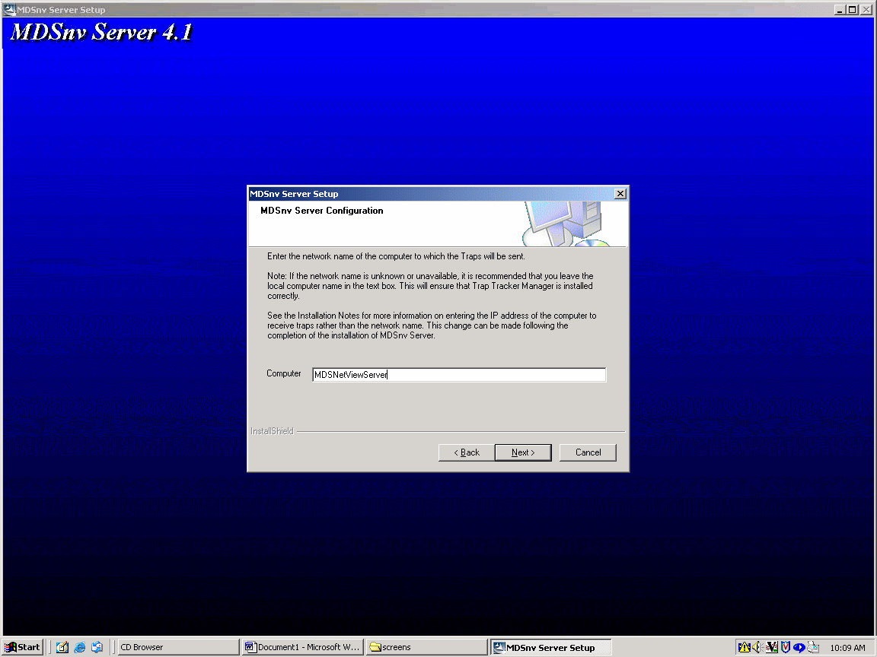
Figure 3: Setup prompt for the network computer name where Traps will be sent.

Setup will then ask for the network computer name where the Traps will be sent (Figure 3). It is recommended that the default computer (which is the computer the Server is being installed on) be used.

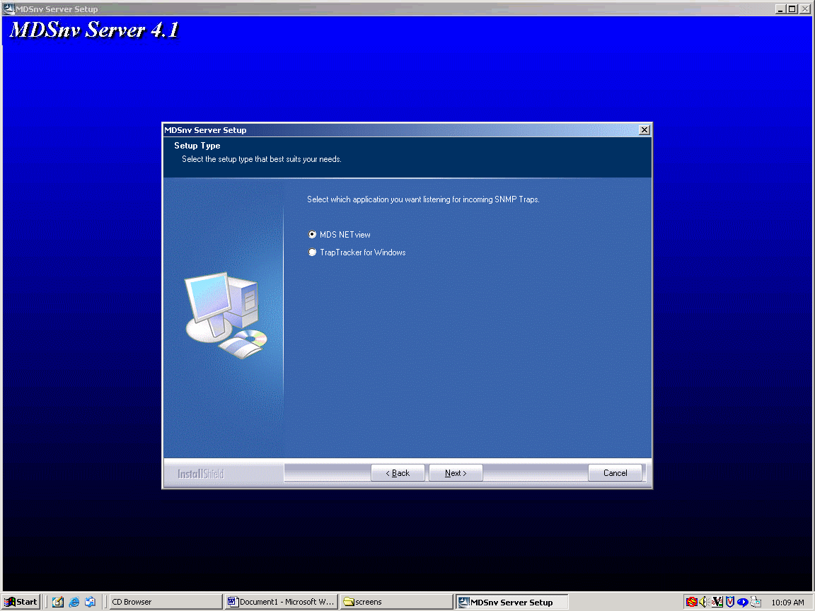
Figure 4: Prompt for which application will listen for SNMP Traps. Default is MDS NETview.

The setup will then ask which application will listen for SNMP Traps: MDS NETview, or TrapTracker for Windows (Figure 4). It is recommended that MDS NETview be used. For information on Installing TrapTracker, please see Installing TrapTracker Manager. Click Next.

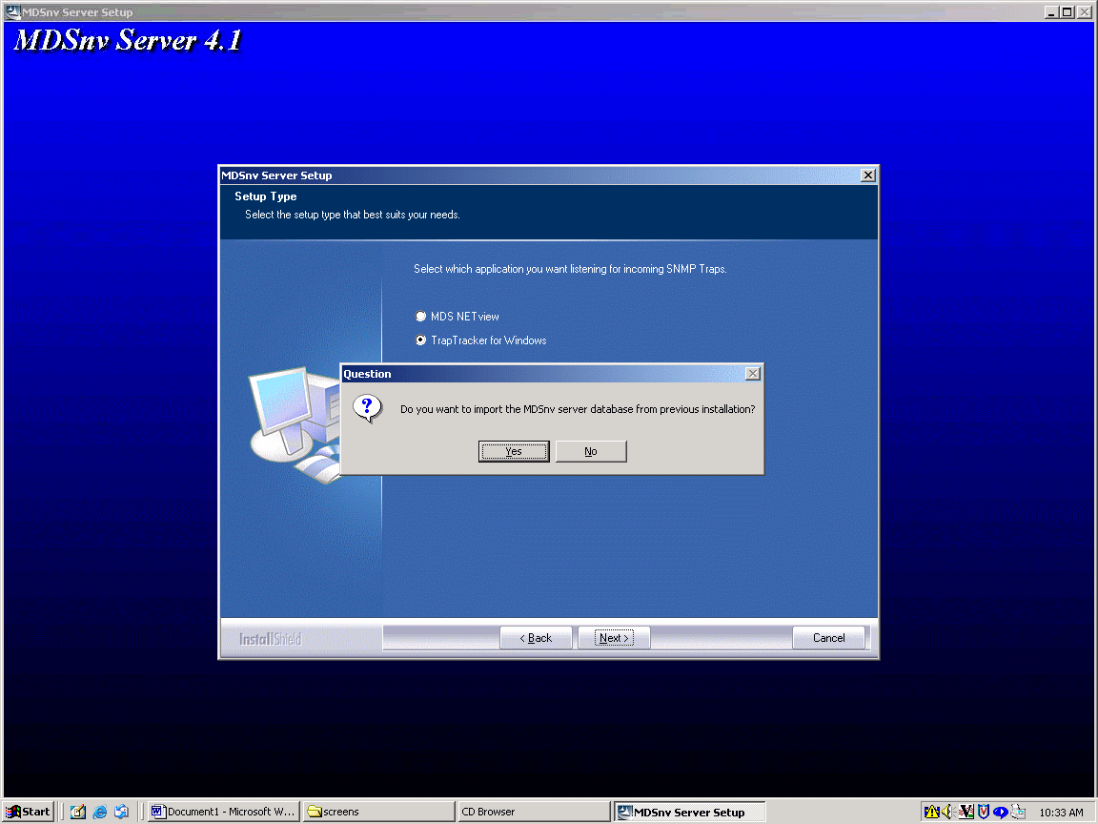
Figure 5: Prompt for importing the previous database file for version 4.1.

Setup will ask if you want to import the previous MDSnv Server database file from a previous installation (Figure 5). It is highly recommended that this be done now as changes have been made to the database setup in version 4.1. When imported, MS Access will perform all the necessary functions to import the previous database into the current version. If this is a fresh install setup will not ask for a database file that does not exist.

Setup will then check for an MDS TFTP Server Installation. If not found, Setup will install the Server. For more Information, see Installing MDS TFTP Server.

MDSnv Server 4.1 has been successfully installed. Installation Notes and other documentation can be found on the installation CD-ROM.

UPDATING A PREVIOUS INSTALLATION OF MDSnv SERVER TO 4.1.

In order to update a previous version of MDSnv Server, you must first uninstall the previous version, and then install MDSnv Server 4.1. See Uninstalling MDSnv Server 4.1 for information on uninstallation, and Installing MDSnv Server 4.1 for information on installation.

UNINSTALLING MDSnv SERVER 4.1

If there is already a version of MDSnv Server on the machine, Setup will automatically run the Uninstallation wizard.

Setup will check for an installation of TrapTracker Manager and uninstall it if found. If TrapTracker is not found, Setup will display a dialog box stating this. If TrapTracker was not installed for this version of MDSnv Server, the dialog box may be ignored.

If a previous version (pre-4.1) is being uninstalled, the Network Monitor service (NetMon) will be uninstalled along with its scheduled run task. Setup will then delete the schedule for purging the database. No input is required.

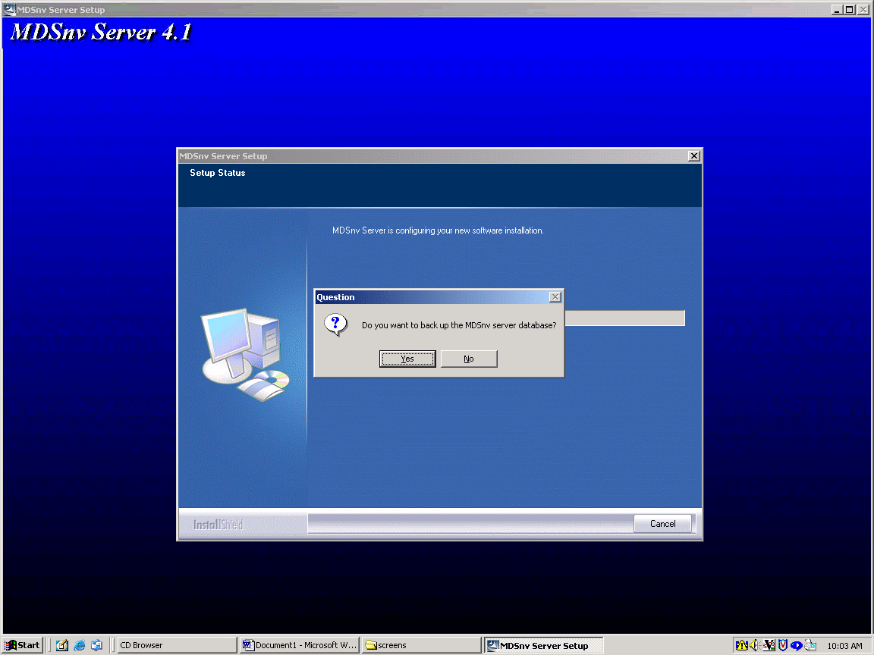
Figure 6: Prompt for backing up the database file.

Setup will ask to back up the server database file (see Figure 6). It is highly recommended that the database be backed up for when you update, or in case you choose to reinstall the server later.

Setup will then remove all files (except the backed up database), and all registry settings.

INSTALLING MDS NETview CLIENT 4.1

Installation of the MDS NETview CLIENT will also check that an up to date version of the Java Runtime Environment is installed. If not installed, the installer will perform the installation of the JRE. After installing the JRE, the user will be prompted to reboot. If the user chooses to reboot, they may have to restart the MDSNETview MS installation.

Setup will install MDS NETview to the folder directory displayed in the “Destination Folder” box. It is recommended that the default folder is kept, however, selecting the browse button and choosing a new folder may change it.

Setup will install the necessary files for MDS NETview to run on this machine.

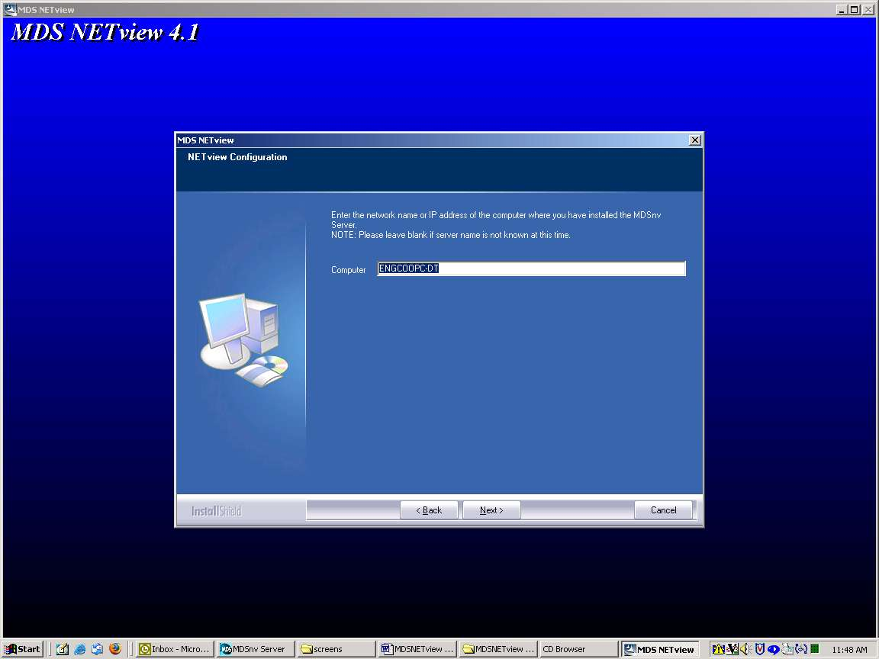
Figure 7: Prompt for name or IP address where the Server was installed.

Setup will then ask for the network name or IP address of the computer where the MDSnv Server was installed (Figure 7). The default computer is the computer MDS NETview is being installed on. If the server name is not known at this time, please leave blank.

MDS NETview 4.1 has been successfully installed on the machine.

UPDATING A PREVIOUS INSTALLATION OF MDS NETview CLIENT TO 4.1.

In order to update a previous version of MDS NETview Client, you must first uninstall the previous version, and then install MDS NETview Client 4.1. See Uninstalling MDS NETview Client 4.1 for information on uninstallation, and Installing MDS NETview Client 4.1 for information on installation.

UNINSTALLING MDS NETview CLIENT 4.1

If there is already a version of MDS NETview installed on the machine, Setup will automatically run the uninstall wizard upon finding an installation.

Setup will then uninstall MDS NETview.

INSTALLING MDS TFTP SERVER

When installing or updating the MDSnv Server, Setup will check for the latest version of the MDS TFTP Server. If not found, Setup will automatically launch the MDS TFTP Server installer. Follow the on-screen instructions to install the TFTP Server.

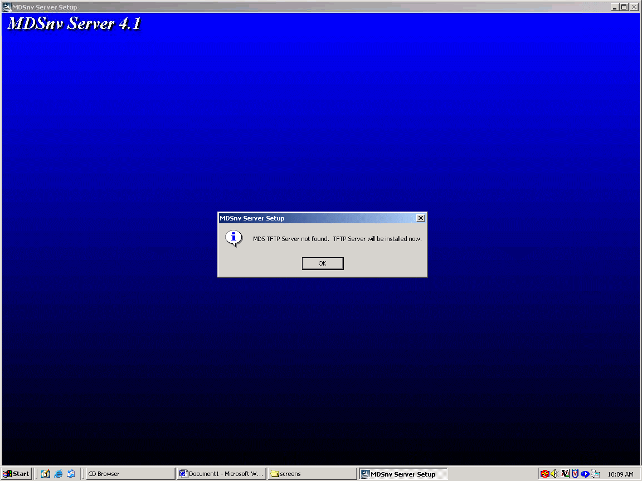
Figure 8: Prompt to continue server setup after TFTP Installation.

Once the MDS TFTP Server has been installed, The MDSnv Server Setup will display a prompt to continue installation (Figure 8). Unlike previous versions, the MDS TFTP Server is set up for the MDSnv Server automatically during installation. No further set up is required.

INSTALLING TRAPTRACKER MANAGER

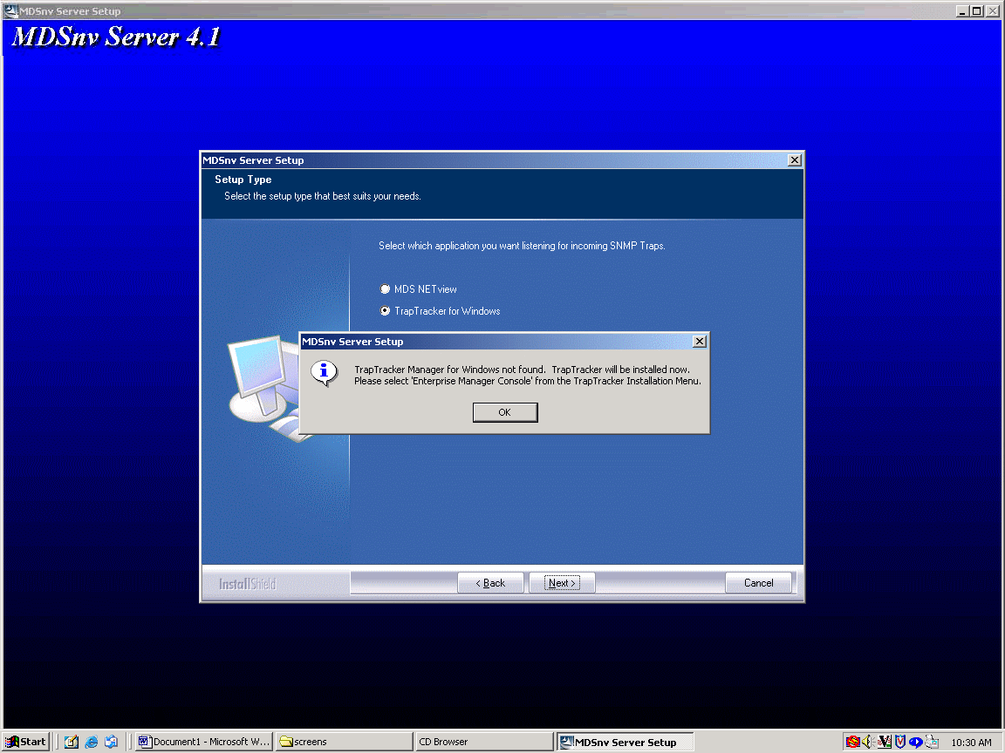
Figure 9: Dialog Box informing user that Trap Tracker will be installed.

Although NETview 4.1 can listen to incoming SNMP Traps on its own, the option is provided to use TrapTracker for Windows instead. If chosen, Setup will search for an installed version of TrapTracker. If not found, Setup will automatically launch the TrapTracker installer (Figure 9). Follow the on-screen instructions.

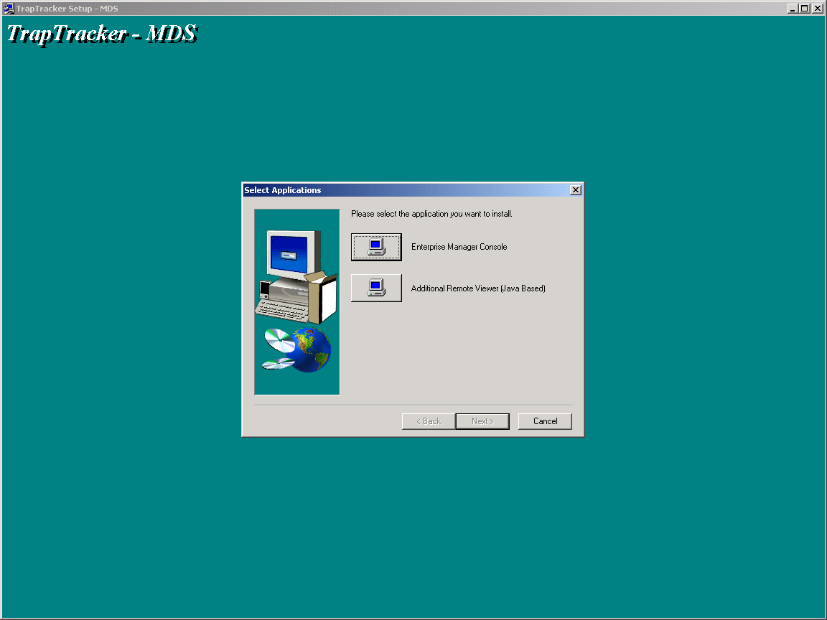
Figure 10: TrapTracker setup asking for which application to install

At one point, Setup will ask which application to install: Enterprise Manager Console or Additional Remote Viewer (Java Based) (Figure 10). Choose the Enterprise Manager Console option. After choosing the folders where to install the program, the TrapTracker Setup will install the program.

After finishing the TrapTracker installation, the MDSnv Server Setup will display a prompt for continuing the setup. Click OK and continue installing the MDSnv Server.

TROUBLESHOOTING

When uninstalling the MDSnv Server, I get the following error message:

Could not delete schedule task for (service). Please delete it manually.

Go to Start->Control Panel->Scheduled Tasks. Find the Task “At1” (and “At2” if uninstalling a previous version of MDSnv Server [pre-4.0.0]). If found, delete the tasks. If not found, the message can be ignored as the scheduled tasks were in fact deleted.

